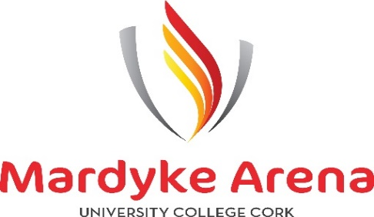

**Gym/Duty Manager**

Mardyke Arena UCC are currently seeking applications for the position of a full time Gym Instructor with assigned Duty Manager Hours within this role. This position will involve working in the Gym when not covering Duty Manager Hours.

The Duty Manager role will primarily involve the efficient and effective day-to-day management of the Mardyke Arena UCC when working specific duty manager hours. The Duty Manager will be a member of the internal management team and will report directly to the General Manager.

**Gym/Duty Manager Duties and Responsibilities:**

* Create a conducive working environment for staff to deliver a consistently high standard of service to customers.
* Ensure the centre, at all times, is managed effectively and safely with a daily focus & action on Health & Safety, Customer Service and Hygiene.
* Proactive management of reporting of operational issues to ensure remedies are timely and effective.
* Provide overall supervision of each department in a manner appropriate to your management function.
* Ability to resolve issues as they arise identify the root cause of the problem and propose solutions.
* Open and/ or close the Mardyke Arena UCC.
* Effectively communicate and co-ordinate with other team members and management.
* Lead and manage all personnel under your remit – ensure good communication flow and engagement is maintained.
* Make day-to-day decisions relating to the efficient and effective operation of the Arena during your rostered hours.
* Be responsible for the overall security and safety of members/visitors and staff of the Arena during your rostered hours.
* To promote the Mardyke Arena UCC and all its services to all patrons and members.
* Work with the HR department to resolve employee issues.
* Help foster a positive working environment for all workers and check in regularly to ensure employee satisfaction.
* Complete daily operational tasks in a timely manner.
* Be a proactive leader especially at the busiest times.
* Ensure compliance of the company’s extensive policies, procedures and processes from an ISO Quality Assurance perspective, a Safeguarding perspective and a Health and Safety perspective.
* Leisure/Business Management qualifications (Reps Ireland recognised).
* Create fitness programmes, monitor, and adapt when needed.
* Providing excellent supervision skills to oversee the use of fitness equipment.
* Ability to work as a part of a team, as well as on own initiative
* The ability to teach fitness classes to a wide range of fitness levels -Desirable, Not Essential.

The ideal candidate would have:

* The ability to build and maintain effective working relationships.
* Supervisory Experience is an advantage.
* Leisure/Business Management Qualification.
* People Management & Operations experience.
* First Aid qualification.
* Flexible with hours including weekends, evenings and bank holidays.
* Excellent customer service and resolution skills.
* Exceptional time-management and task-delegation skills.
* Computer literate and proficient using Microsoft Suite.
* Dynamic personality and strong leadership skills.
* Current and valid REPS & RLSS certification.

A Full training programme will be in place for the successful candidate.

What we offer:

* Competitive Salary
* 20 Days paid annual leave
* 3-Bonus Paid Days at Christmas
* Generous Company Pension Scheme
* 30 Days Paid Sick Leave Annually
* Paid Lunch Breaks
* Sunday & Bank Holiday Allowances
* Membership of the Arena Facilities
* Ongoing Training and Career Development
* Staff Uniform Provided
* Staff Parking
* Staff Reward & Recognition Programme

For more information, please contact Liz at [lizmahr@ucc.ie](mailto:lizmahr@ucc.ie).